SAP TM – Report POD event in the Freight orders and update the POS status in the outbound deliveries and also revoke already reported POD event in case of error.

*----------------------------------------------------------------------*  
*RICEFW ID          :                                                  *  
*Title              : Automate POD event reporting on Freight Order    *  
*Author             : EXT-AGOEL                                        *  
*Creation Date      : 15.03.2024                                       *  
*Package            : ZTM01                                            *  
*Transaction Code   :  ZTM_AUTO_POD_EVENT                               *  
*Transport Request  : DS4K902314                                       *  
*Description        : Automate POD event reporting on Freight Order    *  
*----------------------------------------------------------------------*  
*                         CHANGE HISTORY                               *  
*----------------------------------------------------------------------*  
*Date       | Author  | Transport |Change ID - Description             *                                                                     *  
*DD-MMM-YYYY|          |            |                                     *  
*----------------------------------------------------------------------*  
REPORT ztmr_automate_pod_event_report.  
  
TYPES:BEGIN OF ty_output,  
        freight_order    TYPE /scmtms/tor_id,  
        event_code_descp TYPE /scmtms/description_s,  
        event_timestamp  TYPE timestamp,  
        location         TYPE /scmtms/location_id,  
        remarks          TYPE string,  
      END OF   ty_output.  
  
TYPES:BEGIN OF ty_excel_data,  
        freight_order(20) TYPE c,  
        event_code(20)    TYPE c,  
        event_date(10)    TYPE c,  
        event_time(8)     TYPE c,  
      END OF ty_excel_data.  
  
TYPES:BEGIN OF ty_event_update,  
        fo_key          TYPE /bobf/conf_key,  
        fo_id           TYPE /scmtms/tor_id,  
        exe_key         TYPE /bobf/conf_key,  
        event_timestamp TYPE timestamp,  
      END OF ty_event_update.  
  
DATA:lv_incoterm         TYPE inco1,  
     gv_event_code_descp TYPE /scmtms/description_s.  
  
DATA:gt_output       TYPE STANDARD TABLE OF ty_output,  
     gt_excel_data   TYPE STANDARD TABLE OF ty_excel_data,  
     gt_event_update TYPE STANDARD TABLE OF ty_event_update.  
  
*-----------------------------------------------------------------------  
*Selection Screen  
*-----------------------------------------------------------------------  
SELECTION-SCREEN BEGIN OF BLOCK b1 WITH FRAME TITLE TEXT-001.  
  PARAMETERS:p_manual RADIOBUTTON GROUP g1,  
             p_evtcd  TYPE /scmtms/c_ev_ty-tor_event OBLIGATORY DEFAULT 'POD',  
             p_days   TYPE anzta OBLIGATORY DEFAULT '3'.  
  SELECT-OPTIONS:s_inctrm FOR lv_incoterm OBLIGATORY NO INTERVALS.  
  PARAMETERS:p_bulkup RADIOBUTTON GROUP g1.  
  PARAMETERS:p_file TYPE rlgrap-filename.  
SELECTION-SCREEN END OF BLOCK b1.  
  
AT SELECTION-SCREEN ON VALUE-REQUEST FOR p_file.  
  CALL FUNCTION 'F4_FILENAME'  
    EXPORTING  
      field_name = 'P_FILE'  
    IMPORTING  
      file_name  = p_file.  
  
AT SELECTION-SCREEN OUTPUT.  
  s_inctrm = VALUE #( sign   = 'I'  
                      option = 'EQ'  
                      low    = 'DDP' ).  
  APPEND s_inctrm.  
  
  s_inctrm = VALUE #( sign   = 'I'  
                      option = 'EQ'  
                      low    = 'DAP' ).  
  APPEND s_inctrm.  
  
  s_inctrm = VALUE #( sign   = 'I'  
                      option = 'EQ'  
                      low    = 'DPU' ).  
  APPEND s_inctrm.  
  
*-----------------------------------------------------------------------  
*Processing Logic  
*-----------------------------------------------------------------------  
  INCLUDE ztmi_automate_pod_event_report.  
  
*-----------------------------------------------------------------------  
*START-OF-SELECTION.  
*-----------------------------------------------------------------------  
START-OF-SELECTION.  
  
  DATA:lo_automate_pod_event_report TYPE REF TO lcl_automate_pod_event_report.  
  
  lo_automate_pod_event_report = NEW #( ).  
  
  IF lo_automate_pod_event_report IS BOUND.  
  
    TRY.  
*-----------------------------------------------------------------------  
*Get Frieght orders  
*-----------------------------------------------------------------------  
        IF p_manual EQ abap_true.  
          lo_automate_pod_event_report->get_freight_orders_man( IMPORTING et_fo_key = DATA(lt_fo_create) ).  
        ELSE.  
          lo_automate_pod_event_report->get_freight_orders_xls( IMPORTING et_fo_create = lt_fo_create  
                                                                          et_fo_update = DATA(lt_fo_update) ).  
        ENDIF.  
  
*-----------------------------------------------------------------------  
*Report POD event on the Freight Orders  
*-----------------------------------------------------------------------  
        lo_automate_pod_event_report->report_pod_event( EXPORTING it_fo_key = lt_fo_create ).  
  
*-----------------------------------------------------------------------  
*Update POD event on the Freight Orders  
*-----------------------------------------------------------------------  
        lo_automate_pod_event_report->update_pod_event( EXPORTING it_fo_update = lt_fo_update ).  
  
*-----------------------------------------------------------------------  
*Display event reporting output  
*-----------------------------------------------------------------------  
        lo_automate_pod_event_report->display_event_output( ).  
  
      CATCH /bobf/cx_frw_contrct_violation INTO DATA(lo_exception).  
        DATA(ls_message) = lo_exception->if_t100_message~t100key.  
        MESSAGE ID ls_message-msgid TYPE sy-msgty NUMBER ls_message-msgno  
        WITH ls_message-attr1 ls_message-attr2 ls_message-attr3 ls_message-attr4.  
    ENDTRY.  
  
  ENDIF.  
*-----------------------------------------------------------------------

*Code of INCLUDE ztmi_automate_pod_event_report.

*&---------------------------------------------------------------------*  
*& Include ZTMI_AUTOMATE_POD_EVENT_REPORT  
*&---------------------------------------------------------------------*  
  
CLASS lcl_automate_pod_event_report DEFINITION FINAL.  
  
  PUBLIC SECTION.  
  
    METHODS:get_freight_orders_man EXPORTING et_fo_key TYPE /bobf/t_frw_key RAISING /bobf/cx_frw_contrct_violation.  
  
    METHODS:get_freight_orders_xls EXPORTING et_fo_create TYPE /bobf/t_frw_key  
                                             et_fo_update LIKE gt_event_update.  
  
    METHODS:report_pod_event IMPORTING it_fo_key TYPE /bobf/t_frw_key RAISING /bobf/cx_frw_contrct_violation.  
  
    METHODS:create_pod_event IMPORTING iv_fo_key          TYPE /bobf/conf_key  
                                       iv_last_stop_key   TYPE /bobf/conf_key  
                                       iv_evt_timestamp   TYPE timestamp  
                             EXPORTING ev_event_timestamp TYPE timestamp  
                                       et_failed_key      TYPE /bobf/t_frw_key  
                                       eo_message         TYPE REF TO /bobf/if_frw_message.  
  
    METHODS:update_pod_event IMPORTING it_fo_update LIKE gt_event_update.  
  
    METHODS:revoke_pod_event IMPORTING it_fo_key      TYPE /bobf/t_frw_key  
                                       io_srv_manager TYPE REF TO /bobf/if_tra_service_manager  
                                       io_tra_manager TYPE REF TO /bobf/if_tra_transaction_mgr  
                             EXPORTING et_failed_key  TYPE /bobf/t_frw_key  
                                       eo_message     TYPE REF TO /bobf/if_frw_message.  
  
    METHODS:update_pod_status IMPORTING is_item_node_data TYPE /scmtms/s_tor_item_tr_k  
                              EXPORTING ev_outbound_delv  TYPE vbeln_vl  
                                        et_prot           TYPE tab_prott.  
  
    METHODS:val_pod_status_upd IMPORTING is_item_node_data TYPE /scmtms/s_tor_item_tr_k  
                               EXPORTING ev_outbound_delv  TYPE vbeln_vl  
                                         et_prot           TYPE tab_prott.  
  
    METHODS:display_event_output.  
  
    METHODS:upload_excel_file.  
  
ENDCLASS.  
  
CLASS lcl_automate_pod_event_report IMPLEMENTATION.  
  
  METHOD get_freight_orders_man.  
  
    DATA:lo_srv_tor TYPE REF TO /bobf/if_tra_service_manager,  
         lo_message TYPE REF TO /bobf/if_frw_message.  
  
    DATA:lv_current_timestamp TYPE timestamp,  
         lv_from_timestamp    TYPE timestamp,  
         lv_to_timestamp      TYPE timestamp,  
         lv_from_date         TYPE sy-datum,  
         lv_to_date           TYPE sy-datum.  
  
    DATA:ls_query_info TYPE /bobf/s_frw_query_info.  
  
    DATA:lt_sel_parameters TYPE /bobf/t_frw_query_selparam,  
         lt_stop_node_key  TYPE  /bobf/t_frw_key,  
         lt_root_node_key  TYPE  /bobf/t_frw_key,  
         lt_stop_node_data TYPE /scmtms/t_tor_stop_k,  
         lt_failed_key     TYPE /bobf/t_frw_key,  
         lt_d_exec_tr      TYPE /scmtms/t_tor_exec_tr_k,  
         lt_item_node_data TYPE /scmtms/t_tor_item_tr_k.  
  
    DATA:lr_execution_key TYPE RANGE OF /bobf/s_frw_key-key,  
         lr_item_key      TYPE RANGE OF /bobf/s_frw_key-key.  
  
    CLEAR et_fo_key.  
  
*Instantiate service manager  
    lo_srv_tor = /bobf/cl_tra_serv_mgr_factory=>get_service_manager( /scmtms/if_tor_c=>sc_bo_key ).  
  
*-----------------------------------------------------------------------------------------------  
*Filter Freight Orders with stop category as 'I' and also where the arrival date is 3-4 days old  
*-----------------------------------------------------------------------------------------------  
  
*Prepare selection creteria  
    lt_sel_parameters = VALUE #( ( attribute_name = /scmtms/if_tor_c=>sc_query_attribute-stop-query_by_attributes-stop_cat  
                                   option = 'EQ'  
                                   sign   = 'I'  
                                   low    = 'I') ).  
  
    GET TIME STAMP FIELD lv_current_timestamp.  
    CONVERT TIME STAMP lv_current_timestamp TIME ZONE 'UTC' INTO DATE DATA(lv_date) TIME DATA(lv_time).  
  
    lv_from_date = lv_date - ( p_days + 1 ).  
    CONVERT DATE lv_from_date TIME lv_time DAYLIGHT SAVING TIME 'X' INTO TIME STAMP lv_from_timestamp TIME ZONE 'UTC'.  
  
    lv_to_date   = lv_date - p_days.  
    CONVERT DATE lv_to_date TIME lv_time DAYLIGHT SAVING TIME 'X' INTO TIME STAMP lv_to_timestamp TIME ZONE 'UTC'.  
  
    APPEND VALUE #( attribute_name = /scmtms/if_tor_c=>sc_query_attribute-stop-query_by_attributes-plan_trans_time  
                    option = 'LT'  
                    sign   = 'E'  
                    low    = lv_from_timestamp ) TO lt_sel_parameters.  
  
    APPEND VALUE #( attribute_name = /scmtms/if_tor_c=>sc_query_attribute-stop-query_by_attributes-plan_trans_time  
                    option = 'GT'  
                    sign   = 'E'  
                    low    = lv_to_timestamp ) TO lt_sel_parameters.  
  
*Get key of the selected records as per the selection creteria  
    lo_srv_tor->query(  
      EXPORTING  
        iv_query_key            = /scmtms/if_tor_c=>sc_query-stop-query_by_attributes  
        it_selection_parameters = lt_sel_parameters  
      IMPORTING  
        eo_message              = lo_message  
        es_query_info           = ls_query_info  
        et_key                  = lt_stop_node_key ).  
  
*Get data of the selected records as per the selection creteria  
    IF lt_stop_node_key  IS NOT INITIAL.  
      lo_srv_tor->retrieve( EXPORTING iv_node_key   = /scmtms/if_tor_c=>sc_node-stop  
                                      it_key        = lt_stop_node_key  
                                      iv_edit_mode  = /bobf/if_conf_c=>sc_edit_read_only  
                            IMPORTING eo_message    = lo_message  
                                      et_data       = lt_stop_node_data  
                                      et_failed_key = lt_failed_key ).  
    ENDIF.  
  
    LOOP AT lt_stop_node_data ASSIGNING FIELD-SYMBOL(<lfs_stop_node_data>).  
      APPEND INITIAL LINE TO lt_root_node_key ASSIGNING FIELD-SYMBOL(<lfs_root_node_key>).  
      IF <lfs_root_node_key> IS ASSIGNED.  
        <lfs_root_node_key>-key = <lfs_stop_node_data>-root_key.  
      ENDIF.  
    ENDLOOP.  
  
*--------------------------------------------------------------------------------------  
*Filter Freight Orders where no POD event reported  
*--------------------------------------------------------------------------------------  
  
    IF lt_root_node_key IS NOT INITIAL.  
      lo_srv_tor->retrieve_by_association(  
        EXPORTING  
          iv_node_key    = /scmtms/if_tor_c=>sc_node-root  
          it_key         = lt_root_node_key  
          iv_association = /scmtms/if_tor_c=>sc_association-root-executioninformation_tr  
          iv_fill_data   = abap_true  
        IMPORTING  
          eo_message     = lo_message  
          et_data        = lt_d_exec_tr  
          et_failed_key  = lt_failed_key ).  
  
      DELETE lt_d_exec_tr WHERE event_code NE 'POD'.  
  
      IF lt_d_exec_tr IS NOT INITIAL.  
        lr_execution_key = VALUE #( FOR ls_d_exec_tr IN lt_d_exec_tr  
                                   ( sign           = 'I'  
                                     option         = 'EQ'  
                                     low            = ls_d_exec_tr-root_key ) ).  
  
        DELETE lt_root_node_key WHERE key NOT IN lr_execution_key.  
      ENDIF.  
    ENDIF.  
  
*--------------------------------------------------------------------------------------  
*Filter Freight Orders by Incoterm  
*--------------------------------------------------------------------------------------  
    IF lt_root_node_key IS NOT INITIAL.  
      lo_srv_tor->retrieve_by_association(  
        EXPORTING  
          iv_node_key    = /scmtms/if_tor_c=>sc_node-root  
          it_key         = lt_root_node_key  
          iv_association = /scmtms/if_tor_c=>sc_association-root-item_tr  
          iv_fill_data   = abap_true  
        IMPORTING  
          eo_message     = lo_message  
          et_data        = lt_item_node_data  
          et_failed_key  = lt_failed_key ).  
  
      DELETE lt_item_node_data WHERE item_type NE 'PRD'.  
      DELETE lt_item_node_data WHERE inc_class_code NOT IN s_inctrm.  
  
      IF lt_item_node_data IS NOT INITIAL.  
        lr_item_key = VALUE #( FOR ls_item_node_data IN lt_item_node_data  
                              ( sign           = 'I'  
                                option         = 'EQ'  
                                low            = ls_item_node_data-root_key ) ).  
  
        DELETE lt_root_node_key WHERE key NOT IN lr_item_key.  
      ENDIF.  
    ENDIF.  
  
  ENDMETHOD.  
  
  METHOD report_pod_event.  
  
    TYPES:BEGIN OF ty_outbound_delv,  
            outbound_delv TYPE vbeln_vl,  
          END OF ty_outbound_delv.  
  
    DATA:lv_event_date      TYPE sy-datum,  
         lv_event_timestamp TYPE timestamp.  
  
    DATA:lo_srv_tor     TYPE REF TO /bobf/if_tra_service_manager,  
         lo_message     TYPE REF TO /bobf/if_frw_message,  
         lo_exception   TYPE REF TO /bobf/cx_frw_contrct_violation,  
         lo_exp_message TYPE REF TO /bobf/cm_frw,  
         lo_tra_tor     TYPE REF TO /bobf/if_tra_transaction_mgr.  
  
    DATA:lt_failed_key     TYPE /bobf/t_frw_key,  
         lt_root_node_key  TYPE /bobf/t_frw_key,  
         lt_root_node_data TYPE /scmtms/t_tor_root_k,  
         lt_item_node_data TYPE /scmtms/t_tor_item_tr_k,  
         lt_outbound_delv  TYPE STANDARD TABLE OF ty_outbound_delv,  
         lt_stop_last_data TYPE STANDARD TABLE OF /scmtms/s_tor_stop_k  
                           WITH NON-UNIQUE SORTED KEY parent_cat_role  
                           COMPONENTS parent_key stop_cat stop_role.  
  
    CLEAR gv_event_code_descp.  
  
*---------------------------------------------------------------------------------  
*Get event code description  
*---------------------------------------------------------------------------------  
    IF p_manual EQ abap_true.  
      SELECT SINGLE description_s  
      FROM /scmtms/c_ev_tyt  
      INTO @DATA(lv_evt_code_descp)  
      WHERE tor_event EQ @p_evtcd AND  
            langu     EQ @sy-langu.  
      IF sy-subrc EQ 0.  
        gv_event_code_descp = lv_evt_code_descp.  
      ENDIF.  
    ELSE.  
      SELECT SINGLE description_s  
      FROM /scmtms/c_ev_tyt  
      INTO @lv_evt_code_descp  
      WHERE tor_event EQ 'POD' AND  
            langu     EQ @sy-langu.  
      IF sy-subrc EQ 0.  
        gv_event_code_descp = lv_evt_code_descp.  
      ENDIF.  
    ENDIF.  
  
*Instantiate service manager  
    lo_srv_tor = /bobf/cl_tra_serv_mgr_factory=>get_service_manager( /scmtms/if_tor_c=>sc_bo_key ).  
    lo_tra_tor = /bobf/cl_tra_trans_mgr_factory=>get_transaction_manager( ).  
  
    IF lo_srv_tor IS BOUND AND it_fo_key IS NOT INITIAL.  
  
*---------------------------------------------------------------------------------  
*Get root node data  
*---------------------------------------------------------------------------------  
      lo_srv_tor->retrieve( EXPORTING iv_node_key   = /scmtms/if_tor_c=>sc_node-root  
                                      it_key        = it_fo_key  
                                      iv_edit_mode  = /bobf/if_conf_c=>sc_edit_read_only  
                            IMPORTING eo_message    = lo_message  
                                      et_data       = lt_root_node_data  
                                      et_failed_key = lt_failed_key ).  
  
*---------------------------------------------------------------------------------  
*Get Item node data  
*---------------------------------------------------------------------------------  
      lo_srv_tor->retrieve_by_association( EXPORTING iv_node_key    = /scmtms/if_tor_c=>sc_node-root  
                                                     it_key         = it_fo_key  
                                                     iv_association = /scmtms/if_tor_c=>sc_association-root-item_tr  
                                                     iv_fill_data   = abap_true  
                                           IMPORTING eo_message     = lo_message  
                                                     et_data        = lt_item_node_data  
                                                     et_failed_key  = lt_failed_key ).  
  
*---------------------------------------------------------------------------------  
*Get stop node data  
*---------------------------------------------------------------------------------  
      lo_srv_tor->retrieve_by_association( EXPORTING iv_node_key    = /scmtms/if_tor_c=>sc_node-root  
                                                     it_key         = it_fo_key  
                                                     iv_fill_data   = abap_true  
                                                     iv_association = /scmtms/if_tor_c=>sc_association-root-stop_last  
                                           IMPORTING eo_message     = lo_message  
                                                     et_data        = lt_stop_last_data  
                                                     et_failed_key  = lt_failed_key ).  
  
*---------------------------------------------------------------------------------  
*Report POD Event and Update POD status for the Freight Order  
*---------------------------------------------------------------------------------  
      IF lt_stop_last_data IS NOT INITIAL AND lt_root_node_data IS NOT INITIAL.  
        LOOP AT it_fo_key ASSIGNING FIELD-SYMBOL(<lfs_fo_key>).  
  
          CLEAR lt_root_node_key.  
          lt_root_node_key = VALUE #( ( key = <lfs_fo_key>-key ) ).  
  
*Read last stop key  
          IF line_exists( lt_stop_last_data[ root_key = <lfs_fo_key>-key ] ).  
            DATA(lv_last_stop_key) = lt_stop_last_data[ root_key = <lfs_fo_key>-key ]-key.  
            DATA(lv_last_stop_id)  = lt_stop_last_data[ root_key = <lfs_fo_key>-key ]-log_locid.  
          ENDIF.  
  
*Append data to output  
          APPEND INITIAL LINE TO gt_output ASSIGNING FIELD-SYMBOL(<lfs_output>).  
          IF <lfs_output> IS ASSIGNED.  
            <lfs_output>-event_code_descp = gv_event_code_descp.  
            <lfs_output>-location         = lv_last_stop_id.  
  
            IF line_exists( lt_root_node_data[ key = <lfs_fo_key>-key ] ).  
              <lfs_output>-freight_order = lt_root_node_data[ key = <lfs_fo_key>-key ]-tor_id.  
            ENDIF.  
  
            CALL FUNCTION 'CONVERSION_EXIT_ALPHA_OUTPUT'  
              EXPORTING  
                input  = <lfs_output>-freight_order  
              IMPORTING  
                output = <lfs_output>-freight_order.  
  
*Read event date and time from excel data  
            IF p_bulkup EQ abap_true.  
              IF line_exists( gt_excel_data[ freight_order = <lfs_output>-freight_order ] ).  
  
                DATA(ls_excel_data) = gt_excel_data[ freight_order = <lfs_output>-freight_order ].  
  
                CLEAR lv_event_date.  
                CALL FUNCTION 'CONVERSION_EXIT_IDATE_INPUT'  
                  EXPORTING  
                    input  = ls_excel_data-event_date  
                  IMPORTING  
                    output = lv_event_date.  
  
                CLEAR lv_event_timestamp.  
                CONVERT DATE lv_event_date TIME ls_excel_data-event_time DAYLIGHT SAVING TIME 'X'  
                INTO TIME STAMP lv_event_timestamp TIME ZONE 'UTC'.  
  
                <lfs_output>-event_timestamp = lv_event_timestamp.  
              ENDIF.  
            ENDIF.  
          ENDIF.  
  
*---------------------------------------------------------------------------------  
*Validate POD status update in Outbound deliveries  
*---------------------------------------------------------------------------------  
          CLEAR lt_outbound_delv.  
          LOOP AT lt_item_node_data ASSIGNING FIELD-SYMBOL(<lfs_d_items>) WHERE item_type  EQ 'PRD'  AND  
                                                                                trq_cat    EQ '06'   AND  
                                                                                base_btd_id IS NOT INITIAL.  
            val_pod_status_upd( EXPORTING is_item_node_data = <lfs_d_items>  
                                IMPORTING ev_outbound_delv  = DATA(lv_outbound_delv)  
                                          et_prot           = DATA(lt_pott) ).  
  
            IF line_exists( lt_pott[ msgty = 'E' ] ).  
  
              DATA(ls_pott) = lt_pott[ msgty = 'E' ].  
              CALL FUNCTION 'MESSAGE_TEXT_BUILD'  
                EXPORTING  
                  msgid               = ls_pott-msgid  
                  msgnr               = ls_pott-msgno  
                  msgv1               = ls_pott-msgv1  
                  msgv2               = ls_pott-msgv2  
                  msgv3               = ls_pott-msgv3  
                  msgv4               = ls_pott-msgv4  
                IMPORTING  
                  message_text_output = <lfs_output>-remarks.  
  
              DATA(lv_error) = abap_true.  
              EXIT.  
            ELSE.  
  
              IF lv_outbound_delv IS NOT INITIAL.  
                APPEND INITIAL LINE TO lt_outbound_delv ASSIGNING FIELD-SYMBOL(<lfs_outbound_delv>).  
                IF <lfs_outbound_delv> IS ASSIGNED.  
                  <lfs_outbound_delv>-outbound_delv = lv_outbound_delv.  
                ENDIF.  
              ENDIF.  
  
              CLEAR lv_outbound_delv.  
            ENDIF.  
  
            CLEAR:ls_pott,lt_pott.  
          ENDLOOP.  
  
  
          IF lv_error EQ abap_false.  
  
*---------------------------------------------------------------------------------  
*Dequeue Sales Order  
*---------------------------------------------------------------------------------  
            IF lt_outbound_delv IS NOT INITIAL.  
              SELECT vbeln,  
                     vgbel  
              FROM lips  
              INTO TABLE @DATA(lt_sales_order)  
              FOR ALL ENTRIES IN @lt_outbound_delv  
              WHERE vbeln EQ @lt_outbound_delv-outbound_delv.  
              IF sy-subrc EQ 0.  
                SORT lt_sales_order BY vgbel.  
                DELETE ADJACENT DUPLICATES FROM lt_sales_order COMPARING vgbel.  
  
                LOOP AT lt_sales_order ASSIGNING FIELD-SYMBOL(<lfs_sales_order>).  
                  CALL FUNCTION 'DEQUEUE_EVVBAKE'  
                    EXPORTING  
                      mode_vbak = 'E'  
                      mandt     = sy-mandt  
                      vbeln     = <lfs_sales_order>-vgbel.  
                ENDLOOP.  
              ENDIF.  
            ENDIF.  
  
*---------------------------------------------------------------------------------  
*Create POD Event  
*---------------------------------------------------------------------------------  
            CLEAR:lt_failed_key,lo_message.  
            create_pod_event( EXPORTING iv_fo_key          = <lfs_fo_key>-key  
                                        iv_last_stop_key   = lv_last_stop_key  
                                        iv_evt_timestamp   = lv_event_timestamp  
                              IMPORTING ev_event_timestamp = <lfs_output>-event_timestamp  
                                        et_failed_key      = lt_failed_key  
                                        eo_message         = lo_message ).  
  
            IF lt_failed_key IS NOT INITIAL AND lo_message IS BOUND.  
              lo_message->get_messages( IMPORTING et_message = DATA(lt_message) ).  
              IF lt_message IS NOT INITIAL.  
                <lfs_output>-remarks = lt_message[ 1 ]-message->get_text( ).  
              ENDIF.  
  
              lv_error = abap_true.  
            ELSE.  
  
*---------------------------------------------------------------------------------  
*Update POD status  
*---------------------------------------------------------------------------------  
              LOOP AT lt_item_node_data ASSIGNING <lfs_d_items> WHERE item_type  EQ 'PRD'  AND  
                                                                      trq_cat    EQ '06'   AND  
                                                                      base_btd_id IS NOT INITIAL.  
  
                CLEAR:lv_outbound_delv,lt_pott.  
                update_pod_status( EXPORTING is_item_node_data = <lfs_d_items>  
                                   IMPORTING ev_outbound_delv  = lv_outbound_delv  
                                             et_prot           = lt_pott ).  
  
                IF line_exists( lt_pott[ msgty = 'E' ] ).  
  
                  CLEAR ls_pott.  
                  ls_pott = lt_pott[ msgty = 'E' ].  
                  CALL FUNCTION 'MESSAGE_TEXT_BUILD'  
                    EXPORTING  
                      msgid               = ls_pott-msgid  
                      msgnr               = ls_pott-msgno  
                      msgv1               = ls_pott-msgv1  
                      msgv2               = ls_pott-msgv2  
                      msgv3               = ls_pott-msgv3  
                      msgv4               = ls_pott-msgv4  
                    IMPORTING  
                      message_text_output = <lfs_output>-remarks.  
  
                  revoke_pod_event( EXPORTING it_fo_key      = lt_root_node_key  
                                              io_srv_manager = lo_srv_tor  
                                              io_tra_manager = lo_tra_tor  
                                    IMPORTING et_failed_key  = lt_failed_key  
                                              eo_message     = lo_message ).  
  
                  lv_error = abap_true.  
                  EXIT.  
                ELSE.  
                  IF line_exists( lt_sales_order[ vbeln = lv_outbound_delv ] ).  
                    CALL FUNCTION 'DEQUEUE_EVVBAKE'  
                      EXPORTING  
                        mode_vbak = 'E'  
                        mandt     = sy-mandt  
                        vbeln     = lt_sales_order[ vbeln = lv_outbound_delv ]-vgbel.  
                  ENDIF.  
                ENDIF.  
              ENDLOOP.  
  
            ENDIF.  
          ENDIF.  
  
          IF lv_error EQ abap_false.  
            <lfs_output>-remarks = TEXT-008.  
          ENDIF.  
  
          CLEAR:lv_last_stop_id,lv_error,lv_last_stop_key.  
        ENDLOOP.  
  
      ENDIF.  
    ENDIF.  
  
  ENDMETHOD.  
  
  METHOD create_pod_event.  
  
    DATA:lt_last_stop_key TYPE /bobf/t_frw_key_link,  
         lt_fo_key        TYPE /bobf/t_frw_key,  
         lt_failed_key    TYPE /bobf/t_frw_key.  
  
    DATA:lo_tra_tor TYPE REF TO /bobf/if_tra_transaction_mgr.  
  
    CLEAR:et_failed_key,eo_message,ev_event_timestamp.  
  
*Instantiate transaction manager  
    lo_tra_tor = /bobf/cl_tra_trans_mgr_factory=>get_transaction_manager( ).  
  
    CLEAR lt_last_stop_key.  
    lt_last_stop_key = VALUE #( ( source_key = iv_fo_key  
                                  target_key = iv_last_stop_key ) ).  
  
    IF p_bulkup EQ abap_true.  
      ev_event_timestamp = iv_evt_timestamp.  
    ELSE.  
      GET TIME STAMP FIELD ev_event_timestamp.  
    ENDIF.  
  
    CLEAR lt_fo_key.  
    lt_fo_key = VALUE #( ( key = iv_fo_key ) ).  
  
    CALL METHOD /scmtms/cl_tor_helper_event=>report_event  
      EXPORTING  
        iv_event_code       = 'POD'  
        iv_ref_event_code   = 'POD'  
        it_tor_key          = lt_fo_key  
        it_tor_root_stop    = lt_last_stop_key  
        iv_event_status     = 'R'  
        iv_actual_date      = ev_event_timestamp  
        iv_actual_tz        = 'UTC'  
        iv_exec_info_source = 'T'  
      IMPORTING  
        et_failed_key       = et_failed_key  
        eo_message          = eo_message.  
  
    IF et_failed_key IS INITIAL AND lo_tra_tor IS BOUND.  
      lo_tra_tor->save( ).  
    ENDIF.  
  
  ENDMETHOD.  
  
  METHOD get_freight_orders_xls.  
  
    DATA:lv_event_date      TYPE sy-datum,  
         lv_event_timestamp TYPE timestamp.  
  
    DATA:lt_sel_parameters TYPE /bobf/t_frw_query_selparam,  
         lt_failed_key     TYPE /bobf/t_frw_key,  
         lt_execution_key  TYPE /bobf/t_frw_key,  
         lt_d_exec_tr      TYPE /scmtms/t_tor_exec_tr_k,  
         lt_root_node_data TYPE /scmtms/t_tor_root_k.  
  
    DATA:lo_srv_tor TYPE REF TO /bobf/if_tra_service_manager,  
         lo_message TYPE REF TO /bobf/if_frw_message.  
  
    CLEAR:gt_event_update,et_fo_create,et_fo_update.  
  
*Instantiate service manager  
    lo_srv_tor = /bobf/cl_tra_serv_mgr_factory=>get_service_manager( /scmtms/if_tor_c=>sc_bo_key ).  
  
*Upload data from excel file  
    upload_excel_file( ).  
  
    IF gt_excel_data IS NOT INITIAL.  
  
      CLEAR lt_sel_parameters.  
      LOOP AT gt_excel_data ASSIGNING FIELD-SYMBOL(<lfs_excel_data>).  
        APPEND VALUE #( attribute_name = /scmtms/if_tor_c=>sc_query_attribute-root-fo_data_by_attr-tor_id  
                        option = 'EQ'  
                        sign   = 'I'  
                        low    =  <lfs_excel_data>-freight_order ) TO lt_sel_parameters.  
      ENDLOOP.  
  
      lo_srv_tor->query(  
        EXPORTING  
          iv_query_key            = /scmtms/if_tor_c=>sc_query-root-fo_data_by_attr  
          it_selection_parameters = lt_sel_parameters  
        IMPORTING  
          eo_message              = lo_message  
          et_key                  = et_fo_create ).  
  
      lo_srv_tor->retrieve( EXPORTING iv_node_key   = /scmtms/if_tor_c=>sc_node-root  
                                      it_key        = et_fo_create  
                                      iv_edit_mode  = /bobf/if_conf_c=>sc_edit_read_only  
                            IMPORTING eo_message    = lo_message  
                                      et_data       = lt_root_node_data  
                                      et_failed_key = lt_failed_key ).  
  
*Check if POD event reported or not  
      IF et_fo_create IS NOT INITIAL.  
        lo_srv_tor->retrieve_by_association(  
          EXPORTING  
            iv_node_key    = /scmtms/if_tor_c=>sc_node-root  
            it_key         = et_fo_create  
            iv_association = /scmtms/if_tor_c=>sc_association-root-executioninformation_tr  
            iv_fill_data   = abap_true  
          IMPORTING  
            eo_message     = lo_message  
            et_data        = lt_d_exec_tr  
            et_failed_key  = lt_failed_key ).  
  
        LOOP AT et_fo_create ASSIGNING FIELD-SYMBOL(<lfs_fo_key>).  
  
          DATA(lv_index) = sy-tabix.  
          IF line_exists( lt_d_exec_tr[ parent_key = <lfs_fo_key>-key ] ).  
  
            DATA(lt_d_exec_tr_temp) = lt_d_exec_tr.  
            DELETE lt_d_exec_tr_temp WHERE parent_key NE <lfs_fo_key>-key.  
  
*Get execution key of the POD event  
            CLEAR lt_sel_parameters.  
            lt_sel_parameters = VALUE #( ( attribute_name = /scmtms/if_tor_c=>sc_query_attribute-executioninformation-query_by_attributes-execution_id  
                                           option = 'EQ'  
                                           sign   = 'I'  
                                           low    = lt_d_exec_tr_temp[ 1 ]-execution_id ) ).  
  
            APPEND VALUE #(  attribute_name = /scmtms/if_tor_c=>sc_query_attribute-executioninformation-query_by_attributes-parent_key  
                             option = 'EQ'  
                             sign   = 'I'  
                             low    = lt_d_exec_tr_temp[ 1 ]-parent_key )  TO lt_sel_parameters.  
  
            CLEAR lt_execution_key.  
            lo_srv_tor->query(  
              EXPORTING  
                iv_query_key            = /scmtms/if_tor_c=>sc_query-executioninformation-query_by_attributes  
                it_selection_parameters = lt_sel_parameters  
              IMPORTING  
                eo_message              = lo_message  
                et_key                  = lt_execution_key ).  
  
*Read event date and time from excel file  
            IF line_exists( lt_root_node_data[ key = <lfs_fo_key>-key ] ).  
              DATA(lv_fo_id) = lt_root_node_data[ key = <lfs_fo_key>-key ]-tor_id.  
  
              CALL FUNCTION 'CONVERSION_EXIT_ALPHA_OUTPUT'  
                EXPORTING  
                  input  = lv_fo_id  
                IMPORTING  
                  output = lv_fo_id.  
  
              IF line_exists( gt_excel_data[ freight_order = lv_fo_id ] ).  
                DATA(ls_excel_data) = gt_excel_data[ freight_order = lv_fo_id ].  
  
                CALL FUNCTION 'CONVERSION_EXIT_IDATE_INPUT'  
                  EXPORTING  
                    input  = ls_excel_data-event_date  
                  IMPORTING  
                    output = lv_event_date.  
  
                CLEAR lv_event_timestamp.  
                CONVERT DATE lv_event_date TIME ls_excel_data-event_time DAYLIGHT SAVING TIME 'X'  
                INTO TIME STAMP lv_event_timestamp TIME ZONE 'UTC'.  
              ENDIF.  
            ENDIF.  
  
            APPEND VALUE #( fo_key          = <lfs_fo_key>-key  
                            fo_id           = lv_fo_id  
                            exe_key         = lt_execution_key[ 1 ]-key  
                            event_timestamp = lv_event_timestamp ) TO et_fo_update.  
  
            DELETE et_fo_create INDEX lv_index.  
            CLEAR:lv_fo_id,lv_index,lv_event_date,lv_event_timestamp,lt_d_exec_tr_temp.  
          ENDIF.  
  
        ENDLOOP.  
      ENDIF.  
  
    ENDIF.  
  
  ENDMETHOD.  
  
  METHOD update_pod_status.  
  
    DATA:lv_outbound_del TYPE vbeln_vl,  
         lv_del_item_no  TYPE posnr_vl.  
  
    DATA:ls_vbkok TYPE vbkok.  
  
    DATA:lt_vbpok TYPE vbpok_t,  
         lt_verpo TYPE tvpodvb_t,  
         lt_prot  TYPE tab_prott.  
  
    CLEAR:ev_outbound_delv,et_prot.  
  
    DATA(lv_base_btd_id) = is_item_node_data-base_btd_id.  
    CALL FUNCTION 'CONVERSION_EXIT_ALPHA_OUTPUT'  
      EXPORTING  
        input  = lv_base_btd_id  
      IMPORTING  
        output = lv_base_btd_id.  
  
    CLEAR lv_outbound_del.  
    lv_outbound_del = lv_base_btd_id.  
  
    CALL FUNCTION 'CONVERSION_EXIT_ALPHA_INPUT'  
      EXPORTING  
        input  = lv_outbound_del  
      IMPORTING  
        output = lv_outbound_del.  
  
*Check if the delivery is not yet processed  
    SELECT SINGLE @abap_true  
    FROM likp  
    INTO @DATA(lv_exists)  
    WHERE vbeln EQ @lv_outbound_del AND  
          pdstk EQ 'A'.  
    IF sy-subrc EQ 0.  
  
      CLEAR ls_vbkok.  
      ls_vbkok = VALUE #( podat =  sy-datum  
                          potim =  sy-uzeit  
                          kzpod =  'B' ).  
  
      CLEAR:lv_del_item_no,lt_vbpok,lt_verpo.  
      lv_del_item_no = is_item_node_data-base_btditem_id.  
      lt_vbpok = VALUE #( ( vbeln_vl = lv_outbound_del  
                            posnr_vl = lv_del_item_no  
                            kzpod    = 'X') ).  
  
      CALL FUNCTION 'WS_DELIVERY_UPDATE'  
        EXPORTING  
          vbkok_wa                 = ls_vbkok  
          delivery                 = lv_outbound_del  
          if_error_messages_send_0 = space  
          commit                   = abap_true  
        TABLES  
          tvpod_tab                = lt_verpo  
          vbpok_tab                = lt_vbpok  
          prot                     = et_prot.  
  
      IF line_exists( et_prot[ msgty = 'E' ] ).  
        RETURN.  
      ELSE.  
        ev_outbound_delv = lv_outbound_del.  
      ENDIF.  
  
    ENDIF.  
  
  ENDMETHOD.  
  
  METHOD revoke_pod_event.  
  
    DATA:lt_sel_parameters TYPE /bobf/t_frw_query_selparam,  
         lt_d_exec_tr      TYPE /scmtms/t_tor_exec_tr_k,  
         lt_execution_key  TYPE /bobf/t_frw_key.  
  
    CLEAR:eo_message,et_failed_key.  
  
    io_srv_manager->retrieve_by_association(  
      EXPORTING  
        iv_node_key    = /scmtms/if_tor_c=>sc_node-root  
        it_key         = it_fo_key  
        iv_association = /scmtms/if_tor_c=>sc_association-root-executioninformation_tr  
        iv_fill_data   = abap_true  
      IMPORTING  
        eo_message     = eo_message  
        et_data        = lt_d_exec_tr  
        et_failed_key  = et_failed_key ).  
  
    IF lt_d_exec_tr IS NOT INITIAL.  
      DELETE lt_d_exec_tr WHERE event_code NE 'POD'.  
  
*Get execution key of the recently added POD event  
      CLEAR lt_sel_parameters.  
      lt_sel_parameters = VALUE #( ( attribute_name = /scmtms/if_tor_c=>sc_query_attribute-executioninformation-query_by_attributes-execution_id  
                                     option = 'EQ'  
                                     sign   = 'I'  
                                     low    = lt_d_exec_tr[ 1 ]-execution_id ) ).  
  
      APPEND VALUE #(  attribute_name = /scmtms/if_tor_c=>sc_query_attribute-executioninformation-query_by_attributes-parent_key  
                       option = 'EQ'  
                       sign   = 'I'  
                       low    = it_fo_key[ 1 ]-key )  TO lt_sel_parameters.  
  
      CLEAR lt_execution_key.  
      io_srv_manager->query(  
        EXPORTING  
          iv_query_key            = /scmtms/if_tor_c=>sc_query-executioninformation-query_by_attributes  
          it_selection_parameters = lt_sel_parameters  
        IMPORTING  
          eo_message              = eo_message  
          et_key                  = lt_execution_key ).  
  
      io_srv_manager->do_action( EXPORTING it_key        = lt_execution_key  
                                           iv_act_key    = /scmtms/if_tor_c=>sc_action-executioninformation-revoke_event  
                                 IMPORTING et_failed_key = et_failed_key  
                                           eo_message    = eo_message ).  
  
      IF io_tra_manager IS BOUND AND et_failed_key IS INITIAL.  
        io_tra_manager->save( ).  
      ENDIF.  
  
    ENDIF.  
  
  ENDMETHOD.  
  
  METHOD display_event_output.  
  
    DATA:lo_column       TYPE REF TO cl_salv_column,  
         lo_alv_toolbar  TYPE REF TO cl_salv_functions_list,  
         lo_cols         TYPE REF TO cl_salv_columns,  
         lo_table_descr  TYPE REF TO cl_abap_tabledescr,  
         lo_struct_descr TYPE REF TO cl_abap_structdescr,  
         lo_alv          TYPE REF TO cl_salv_table,  
         lo_print        TYPE REF TO cl_salv_print..  
  
    DATA:lv_long_text   TYPE scrtext_l,  
         lv_medium_text TYPE scrtext_m,  
         lv_short_text  TYPE scrtext_s.  
  
    DATA:ls_fieldcat TYPE lvc_t_fcat,  
         ls_pparams  TYPE pri_params.  
  
    DATA:lt_columns TYPE abap_compdescr_tab.  
  
    IF gt_output IS NOT INITIAL.  
      TRY.  
          cl_salv_table=>factory(  
            IMPORTING  
              r_salv_table = lo_alv  
            CHANGING  
              t_table      = gt_output ).  
  
*Add column heading  
          lo_cols = lo_alv->get_columns( ).  
          lo_cols->set_optimize( abap_true ).  
  
*Get columns  
          lo_table_descr ?= cl_abap_typedescr=>describe_by_data( gt_output ).  
          lo_struct_descr ?= lo_table_descr->get_table_line_type( ).  
          lt_columns = lo_struct_descr->components.  
  
          LOOP AT lt_columns ASSIGNING FIELD-SYMBOL(<lfs_column>).  
            TRY.  
                lo_column = lo_cols->get_column( <lfs_column>-name ).  
  
                CLEAR:lv_long_text,  
                      lv_medium_text,  
                      lv_short_text.  
  
                IF <lfs_column>-name EQ 'FREIGHT_ORDER'.  
                  lv_long_text   = TEXT-002.  
                  lv_medium_text = TEXT-002.  
                  lv_short_text  = TEXT-002.  
                ELSEIF <lfs_column>-name EQ 'EVENT_CODE_DESCP'.  
                  lv_long_text   = TEXT-003.  
                  lv_medium_text = TEXT-003.  
                  lv_short_text  = TEXT-003.  
                ELSEIF <lfs_column>-name EQ 'EVENT_TIMESTAMP'.  
                  lv_long_text   = TEXT-004.  
                  lv_medium_text = TEXT-004.  
                  lv_short_text  = TEXT-004.  
                ELSEIF <lfs_column>-name EQ 'LOCATION'.  
                  lv_long_text   = TEXT-005.  
                  lv_medium_text = TEXT-005.  
                  lv_short_text  = TEXT-005.  
                ELSEIF <lfs_column>-name EQ 'REMARKS'.  
                  lv_long_text   = TEXT-006.  
                  lv_medium_text = TEXT-006.  
                  lv_short_text  = TEXT-006.  
                ENDIF.  
  
                lo_column->set_long_text( lv_long_text ).  
                lo_column->set_medium_text( lv_medium_text ).  
                lo_column->set_short_text( lv_short_text ).  
  
              CATCH cx_salv_not_found.  
            ENDTRY.  
          ENDLOOP.  
  
*Display ALV output in foreground mode or print same output in spool in background mode  
          IF sy-batch EQ abap_false.  
            lo_alv_toolbar = lo_alv->get_functions( ).  
            lo_alv_toolbar->set_all( value = if_salv_c_bool_sap=>true ).  
          ELSE.  
            lo_print = lo_alv->get_print( ).  
  
            CALL FUNCTION 'GET_PRINT_PARAMETERS'  
              EXPORTING  
                no_dialog              = abap_true  
              IMPORTING  
                out_parameters         = ls_pparams  
              EXCEPTIONS  
                archive_info_not_found = 1  
                invalid_print_params   = 2  
                invalid_archive_params = 3  
                OTHERS                 = 4.  
  
            CONCATENATE TEXT-007 '_' sy-datum '_' sy-uzeit INTO ls_pparams-prtxt SEPARATED BY space.  
            CONDENSE ls_pparams-prtxt.  
  
            IF lo_print IS BOUND.  
              DATA(ls_print_ctrl) = lo_print->get_print_control( ).  
              ls_print_ctrl-pri_params = ls_pparams.  
              lo_print->set_print_control( ls_print_ctrl ).  
              lo_print->set_print_only( if_salv_c_bool_sap=>true ).  
            ENDIF.  
  
          ENDIF.  
  
          lo_alv->display( ).  
  
        CATCH cx_salv_msg INTO DATA(lx_msg).  
      ENDTRY.  
    ELSE.  
      MESSAGE s000(ztm01) DISPLAY LIKE 'E'.  
      LEAVE LIST-PROCESSING.  
    ENDIF.  
  
  ENDMETHOD.  
  
  METHOD upload_excel_file.  
  
    DATA:lt_raw TYPE truxs_t_text_data.  
  
    CALL FUNCTION 'TEXT_CONVERT_XLS_TO_SAP'  
      EXPORTING  
        i_line_header        = 'X'  
        i_tab_raw_data       = lt_raw  
        i_filename           = p_file  
      TABLES  
        i_tab_converted_data = gt_excel_data[]  
      EXCEPTIONS  
        conversion_failed    = 1  
        OTHERS               = 2.  
    IF sy-subrc <> 0.  
      MESSAGE ID sy-msgid TYPE sy-msgty NUMBER sy-msgno WITH sy-msgv1 sy-msgv2 sy-msgv3 sy-msgv4.  
    ENDIF.  
  
  ENDMETHOD.  
  
  METHOD update_pod_event.  
  
    DATA:lo_srv_tor TYPE REF TO /bobf/if_tra_service_manager,  
         lo_tra_tor TYPE REF TO /bobf/if_tra_transaction_mgr,  
         lo_message TYPE REF TO /bobf/if_frw_message.  
  
    DATA:lr_exec TYPE REF TO /scmtms/s_tor_exec_k.  
  
    DATA:lt_mod            TYPE /bobf/t_frw_modification,  
         lt_failed_key     TYPE /bobf/t_frw_key,  
         lt_root_node_key  TYPE /bobf/t_frw_key,  
         lt_stop_last_data TYPE STANDARD TABLE OF /scmtms/s_tor_stop_k WITH NON-UNIQUE SORTED KEY parent_cat_role  
                           COMPONENTS parent_key stop_cat stop_role.  
  
    IF it_fo_update IS NOT INITIAL.  
  
*Instantiate service and transaction manager  
      lo_srv_tor = /bobf/cl_tra_serv_mgr_factory=>get_service_manager( /scmtms/if_tor_c=>sc_bo_key ).  
      lo_tra_tor = /bobf/cl_tra_trans_mgr_factory=>get_transaction_manager( ).  
  
*Get stop node data  
      lt_root_node_key = VALUE #( FOR ls_fo_update IN it_fo_update  
                                ( key = ls_fo_update-fo_key ) ).  
  
      lo_srv_tor->retrieve_by_association( EXPORTING iv_node_key    = /scmtms/if_tor_c=>sc_node-root  
                                                     it_key         = lt_root_node_key  
                                                     iv_fill_data   = abap_true  
                                                     iv_association = /scmtms/if_tor_c=>sc_association-root-stop_last  
                                           IMPORTING eo_message     = lo_message  
                                                     et_data        = lt_stop_last_data  
                                                     et_failed_key  = lt_failed_key ).  
  
      DELETE lt_stop_last_data WHERE stop_cat NE 'I'.  
  
      LOOP AT it_fo_update ASSIGNING FIELD-SYMBOL(<lfs_fo_update>).  
  
        APPEND INITIAL LINE TO gt_output ASSIGNING FIELD-SYMBOL(<lfs_output>).  
        IF <lfs_output> IS ASSIGNED.  
          <lfs_output>-freight_order    = <lfs_fo_update>-fo_id.  
          <lfs_output>-event_code_descp = gv_event_code_descp.  
          <lfs_output>-event_timestamp  = <lfs_fo_update>-event_timestamp.  
  
          IF line_exists( lt_stop_last_data[ root_key = <lfs_fo_update>-fo_key ] ).  
            <lfs_output>-location = lt_stop_last_data[ root_key = <lfs_fo_update>-fo_key ]-log_locid.  
          ENDIF.  
        ENDIF.  
  
        CREATE DATA lr_exec.  
        lr_exec->actual_date = <lfs_fo_update>-event_timestamp.  
  
        CLEAR lt_mod.  
        INSERT VALUE #( change_mode = /bobf/if_frw_c=>sc_modify_update  
                        node        = /scmtms/if_tor_c=>sc_node-executioninformation  
                        key         = <lfs_fo_update>-exe_key  
                        data        = lr_exec  
                        changed_fields = VALUE #( ( /scmtms/if_tor_c=>sc_node_attribute-executioninformation-actual_date ) ) )  
        INTO TABLE lt_mod.  
  
        CALL METHOD lo_srv_tor->modify  
          EXPORTING  
            it_modification = lt_mod  
          IMPORTING  
            eo_message      = lo_message.  
  
        CALL METHOD lo_tra_tor->save( ).  
  
        <lfs_output>-remarks = TEXT-009.  
  
      ENDLOOP.  
  
    ENDIF.  
  
  ENDMETHOD.  
  
  METHOD val_pod_status_upd.  
  
    DATA:lv_outbound_del TYPE vbeln_vl,  
         lv_del_item_no  TYPE posnr_vl.  
  
    DATA:ls_vbkok TYPE vbkok.  
  
    DATA:lt_vbpok TYPE vbpok_t,  
         lt_verpo TYPE tvpodvb_t.  
  
    CLEAR:ev_outbound_delv,et_prot.  
  
    DATA(lv_base_btd_id) = is_item_node_data-base_btd_id.  
    CALL FUNCTION 'CONVERSION_EXIT_ALPHA_OUTPUT'  
      EXPORTING  
        input  = lv_base_btd_id  
      IMPORTING  
        output = lv_base_btd_id.  
  
    CLEAR lv_outbound_del.  
    lv_outbound_del = lv_base_btd_id.  
  
    CALL FUNCTION 'CONVERSION_EXIT_ALPHA_INPUT'  
      EXPORTING  
        input  = lv_outbound_del  
      IMPORTING  
        output = lv_outbound_del.  
  
*Check if the delivery is not yet processed  
    SELECT SINGLE @abap_true  
    FROM likp  
    INTO @DATA(lv_exists)  
    WHERE vbeln EQ @lv_outbound_del AND  
          pdstk EQ 'A'.  
    IF sy-subrc EQ 0.  
  
      CLEAR ls_vbkok.  
      ls_vbkok = VALUE #( podat =  sy-datum  
                          potim =  sy-uzeit  
                          kzpod =  'B' ).  
  
      CLEAR:lv_del_item_no,lt_vbpok,lt_verpo.  
      lv_del_item_no = is_item_node_data-base_btditem_id.  
      lt_vbpok = VALUE #( ( vbeln_vl = lv_outbound_del  
                            posnr_vl = lv_del_item_no  
                            kzpod    = 'X') ).  
  
      CALL FUNCTION 'WS_DELIVERY_UPDATE'  
        EXPORTING  
          vbkok_wa                 = ls_vbkok  
          delivery                 = lv_outbound_del  
          if_error_messages_send_0 = space  
          commit                   = abap_false  
          if_database_update       = '2'  
        TABLES  
          tvpod_tab                = lt_verpo  
          vbpok_tab                = lt_vbpok  
          prot                     = et_prot.  
  
      IF line_exists( et_prot[ msgty = 'E' ] ).  
        RETURN.  
      ELSE.  
        ev_outbound_delv = lv_outbound_del.  
  
        CALL FUNCTION 'DEQUEUE_EVVBLKE'  
          EXPORTING  
            mode_likp = 'E'  
            mandt     = sy-mandt  
            vbeln     = lv_outbound_del.  
      ENDIF.  
    ENDIF.  
  
  ENDMETHOD.  
  
ENDCLASS.

Unit test Results:

n below:

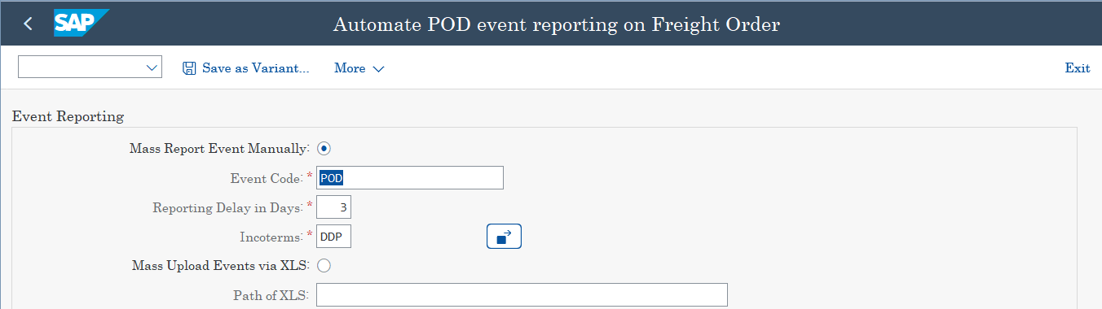

Foreground Mode:

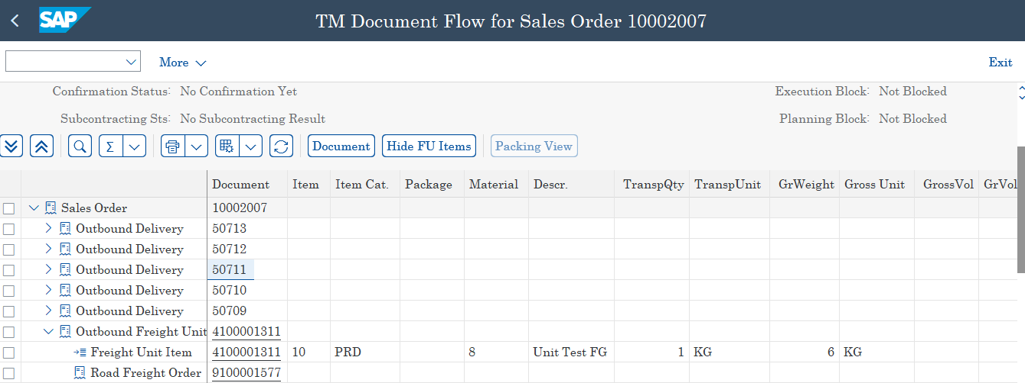

Note: Outbound deliveries - 50710,50711,50712 are skipped at runtime for now as PGI is not done for them.

Upload attached file with below data:

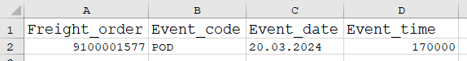

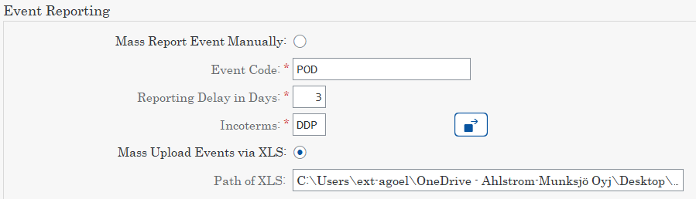

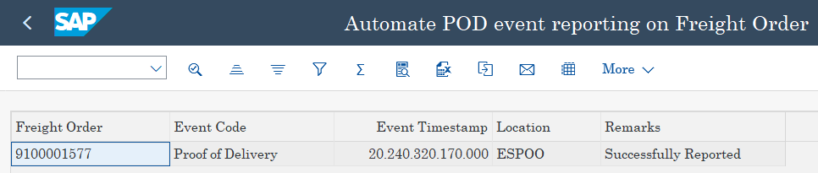

POD Event successfully reported

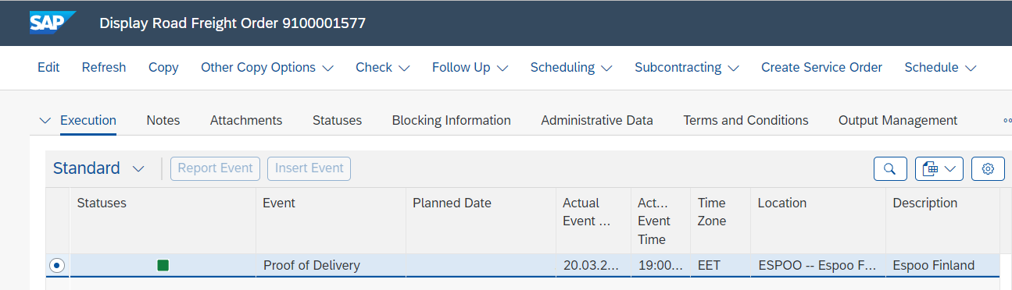

POD status successfully updated in the outbound deliveries:

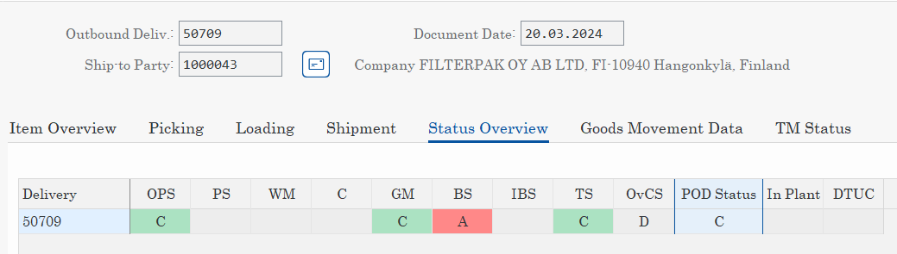

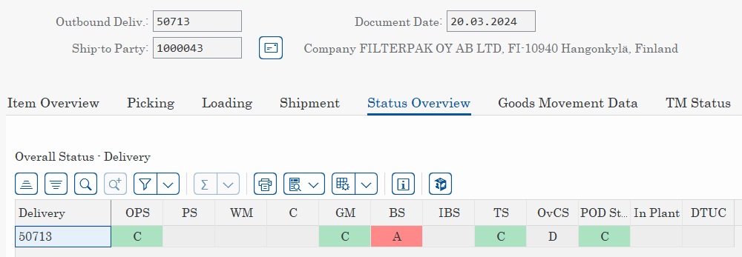

Note:

1. In case of executing the report in background mode, output will be available in spool as shown below:

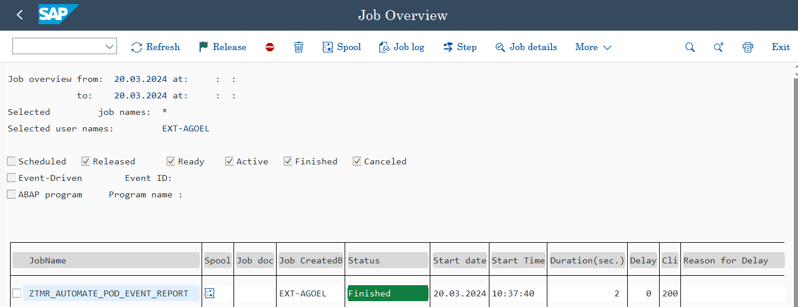

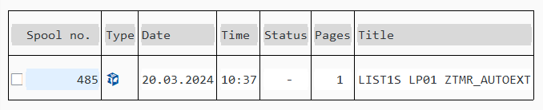

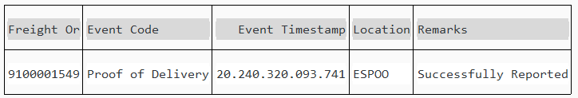

1. If the POD event is already existing against the Freight order uploaded in the excel file, then its actual date timestamp will be updated from the excel file.